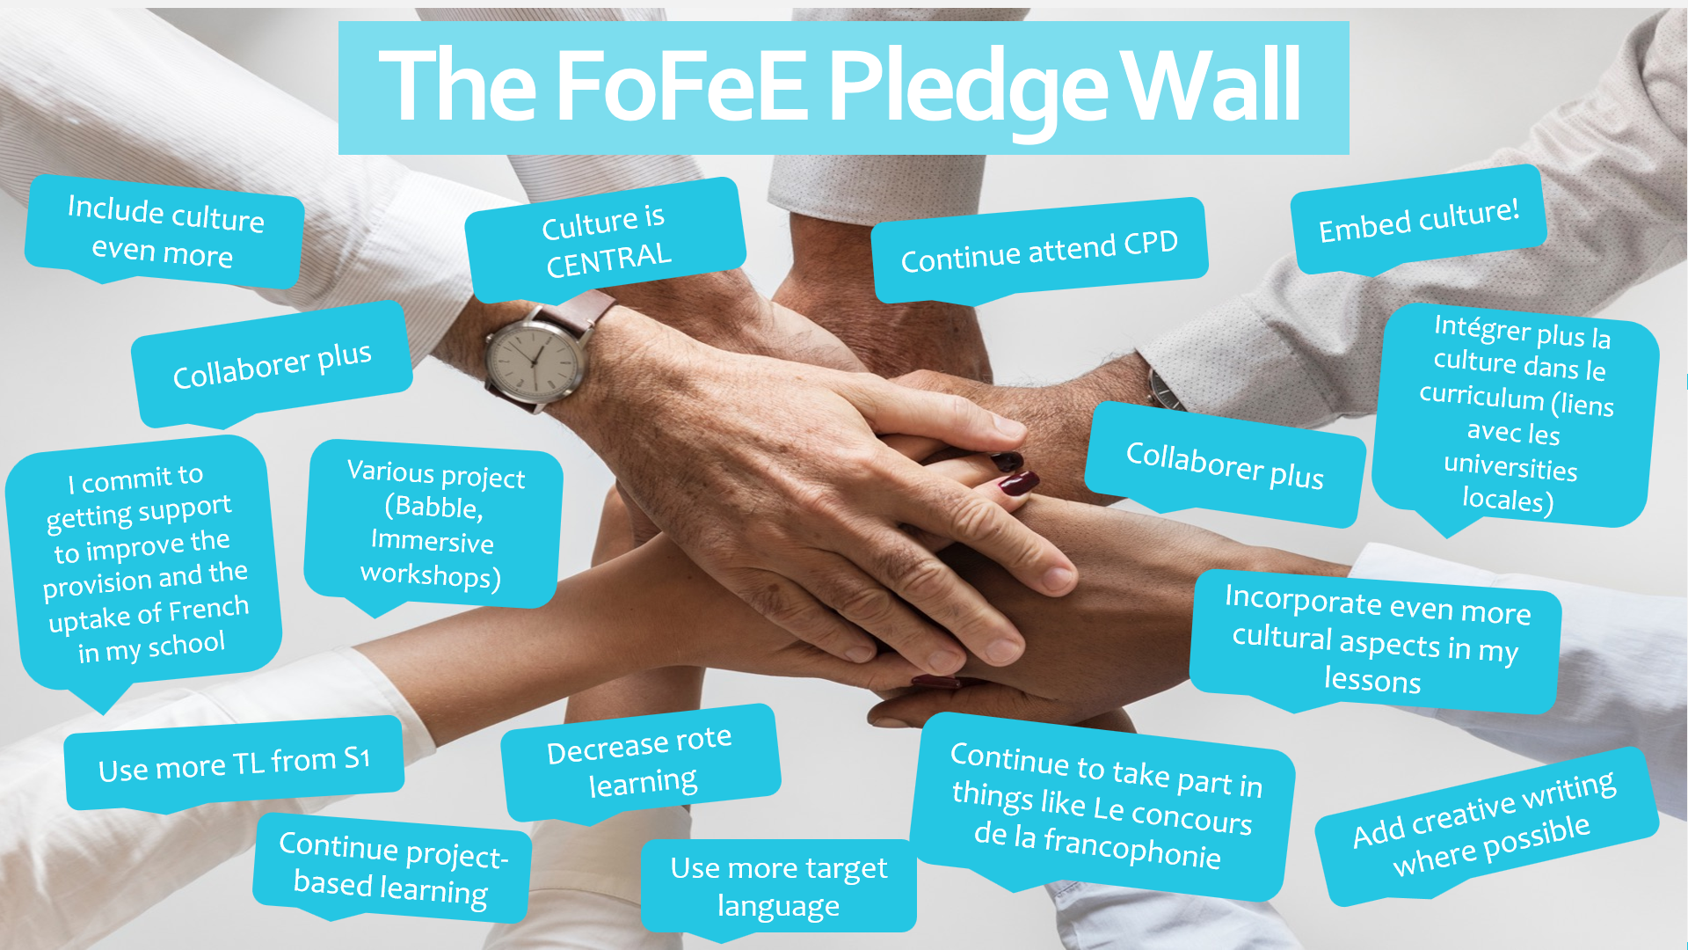
Appendix 3: Pledge Wall

